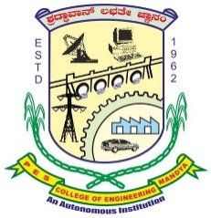
P.E.S COLLEGE OF ENGINEERING, MANDYA
(An Autonomous Institution under Visvesvaraya Technological University, Belgaum
Aided by the Govt. of Karnataka)

Please affix recent passport (35x35mm)Photograph

Application for the post of Principal

Personal  Information | Name
Personal  Information | Date of Birth

Address | Correspondence
Address | Permanent
Address | Email
Address | Mobile No.

Education  Qualification | Qualification | Specialization | Class | Institute / University | Year
Education  Qualification | Ph. D
Education  Qualification | M.Tech
Education  Qualification | BE

Awards / Honors
Research Areas of Interest

Funded Projects | Completed  Ongoing

Patents | Granted  Published

Administrative responsibilities

Experience
Name of the Institute / Industry | Designation | Period | Total Service

List of Journal Publications

Research Guidance | Number of scholars awarded Ph. D
Research Guidance | Number of scholars under supervision

References (Two – provide contact details)
1. | 2.

Signature and Date
Attach attested copies of following documents:
- SSLC & PUC marks card, UG, PG and Ph. D certificates
- Front page of all journal publications
- Relevant details of Ph. D scholars awarded
- Experience certificates
- Aadhaar and PAN card
- Any other documents to support your claim
A Demand Draft of Rs 1000/- drawn in favour of The Principal, P.E.S. College of Engineering, Mandya, and the duly filled in application along with copies of testimonials and other certificates duly attested by a Gazetted Officer should be submitted to the address mentioned below, on or before May 14th, 2026, 5.00 p.m. Applications received after the due date will not be considered.
To:
The Principal
P.E.S College of Engineering,
Mandya – 571401
Phone No. =91 8232-220043, 238683, 238042

